VISVESVARAYA TECHNOLOGICAL UNIVERSITY
Jnana Sangama, Belgavi – 590018.

Report on

“Spam Email Detection using Machine Learning”

Submitted in partial fulfillment of the requirements of the award of degree of

BACHELOR OF ENGINEERING
IN
ARTIFICIAL INTELLIGENCE AND DATA SCIENCE

Submitted By:

MAREDDY CHARAN 1SJ22AD024

UNDER THE GUIDANCE OF

SANDHYA R

ASSISTANT PROFESSOR
DEPARTMENT OF ARTIFICIAL INTELLIGENCE AND DATA SCIENCE, SJCIT

SJC INSTITUTE OF TECHNOLOGY
DEPARTMENT OF ARTIFICIAL INTELLIGENCE AND DATA SCIENCE, CHICKBALLAPUR-562102

Spam email detection using Machine Learning

Problem solving Technique: Spam Email Detection is a classic application of Natural Language Processing (NLP) and machine learning, aimed at automatically classifying email or message content as either spam (unwanted or malicious) or ham (legitimate). The process typically begins by collecting a dataset of labeled messages—where each message is tagged as spam or not spam. These textual messages are then converted into a numerical format that a machine learning model can understand, often using techniques like Bag of Words or TF-IDF, which count word occurrences or assign importance to words based on their frequency across messages.
Step 1: Importing Libraries and Dataset

Using Pandas,Numpy, Matplotlib/Seaborn, Sklearn, XGBoost and Imblearn.
import pandas as pd
import numpy as np
import seaborn as sns
import matplotlib.pyplot as plt
from sklearn.model_selection import train_test_split
from sklearn.feature_extraction.text import CountVectorizer
from sklearn.naive_bayes import MultinomialNB
from sklearn.metrics import classification_report, confusion_matrixNow let's load the dataset into the pandas data frame and print its first five rows. You can download dataset from here.
diabetes = load_diabetes(
df = pd.DataFrame(diabetes.data, columns=diabetes.feature_names)
df['target'] = diabetes.target
print("First 5 rows of the dataset:")
print(df.head())
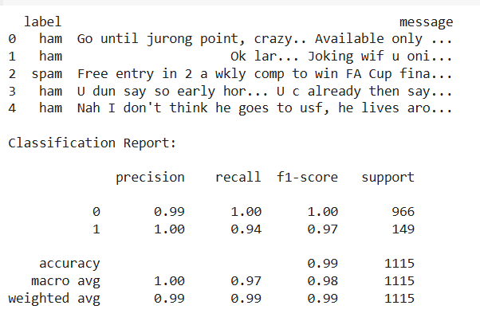
Output 1: First Five rows of the dataset

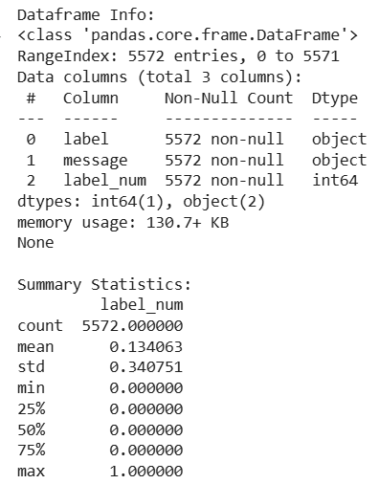
Output 2: Information regarding data in the columns
As per the above information regarding the data in each column we can observe that there are no null values.
print("\n Descriptive Statistics:")
print(df.describe())

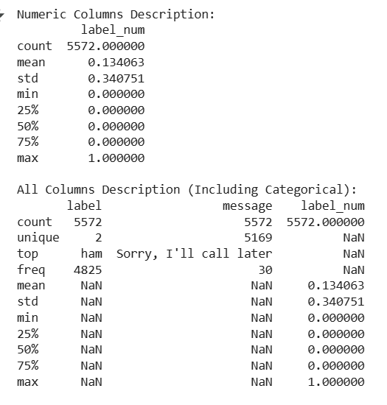
Output 3: Descriptive statistical measures of the dataset

Step 2: Data Cleaning

The data which is obtained from the primary sources is raw data and require a lot of preprocessing before we can derive any conclusions from it. Those preprocessing steps are known as data cleaning and it includes outliers removal, null value imputation and removing discrepancies in the data.
for col in df_cleaned.select_dtypes(include=['object']):
df_cleaned[col] = df_cleaned[col].str.strip()

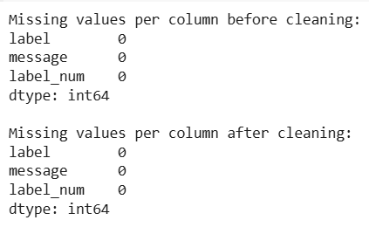
Output 4:value_count of each unique value in the column
The same is the case with this column so let's clean this data and along with this let's convert 'yes' and 'no' to 0 and 1.
df = df.replace({'yes':1, 'no':0, '?':'Others', 'others':'Others'})
Now we have cleaned the data a bit to derive insights from it.

Step 3: Exploratory Data Analysis
Exploratory Data Analysis (EDA) is an approach to analyzing the data using visual techniques. It is used to discover trends and patterns to check assumptions with the help of statistical summaries and graphical representations. Here we will see how to check the data imbalance and skewness of the data.
plt.pie(sizes, labels=labels, colors=colors, autopct='%1.1f%%', startangle=140)
plt.show()

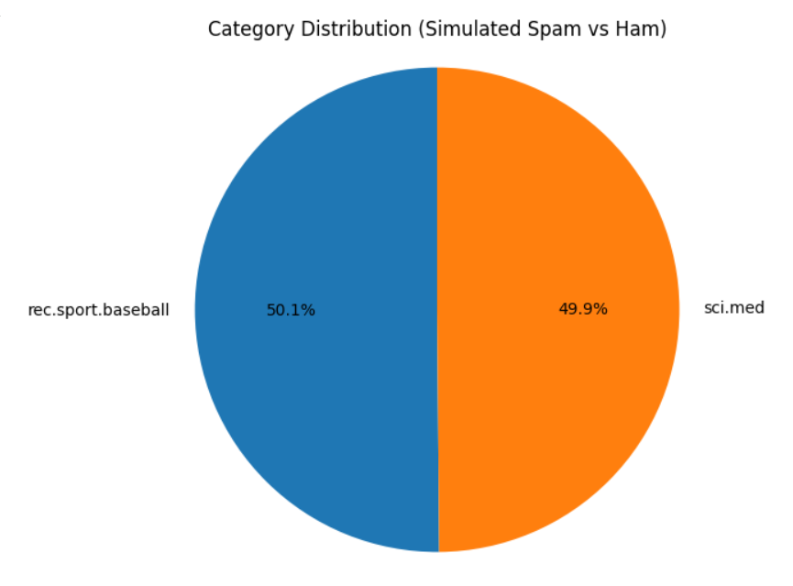

Output 5: Pie chart for the number of data for each target

The dataset we have is highly imbalanced. If we will train our model using this data then the model will face a hard time predicting the positive class which is our main objective here to predicting spam emails.
ints = []
objects = []
floats = []

for col in df.columns:
if df[col].dtype == int:
ints.append(col)
elif df[col].dtype == object:
objects.append(col)
else:
floats.append(col)
Now, we have columns segregated based on the type of data they contain hence now we'll be able to perform suitable analysis depending upon the type of data.
Ambiguity generation in the context of spam email detection refers to identifying uncertain, vague, or ill-defined aspects of the problem that could lead to different interpretations or modeling approaches. Generating ambiguity is useful in research, requirement analysis, or when exploring system limitations or improvement areas.

fig, axes = plt.subplots(1, 2, figsize=(14, 5))
plt.tight_layout()
plt.show()

Output:

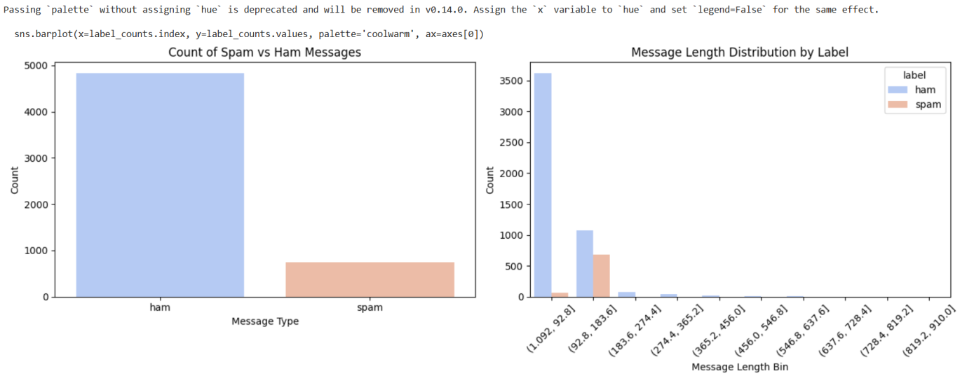
Output 6: Count plots for each of the numerical column
From these plots, we can conclude that if the score of some indicator is 0 then the chances of that person not having autism is quite high except in the case of A10_Score.
fig, axes = plt.subplots(1, 2, figsize=(12, 5))

# Classic color list
classic_colors = ['skyblue', 'salmon']

# Subplot 1: Spam vs Ham counts
label_counts = df['label'].value_counts()
axes[0].bar(label_counts.index, label_counts.values, color=classic_colors)
axes[0].set_title('Message Type Count')
axes[0].set_xlabel('Label')
axes[0].set_ylabel('Count')

# Subplot 2: Average message length by label
avg_length = df.groupby('label')['msg_length'].mean()
axes[1].bar(avg_length.index, avg_length.values, color=classic_colors)
axes[1].set_title('Average Message Length')
axes[1].set_xlabel('Label')
axes[1].set_ylabel('Avg Length')

# Layout and show
plt.tight_layout()
plt.show()

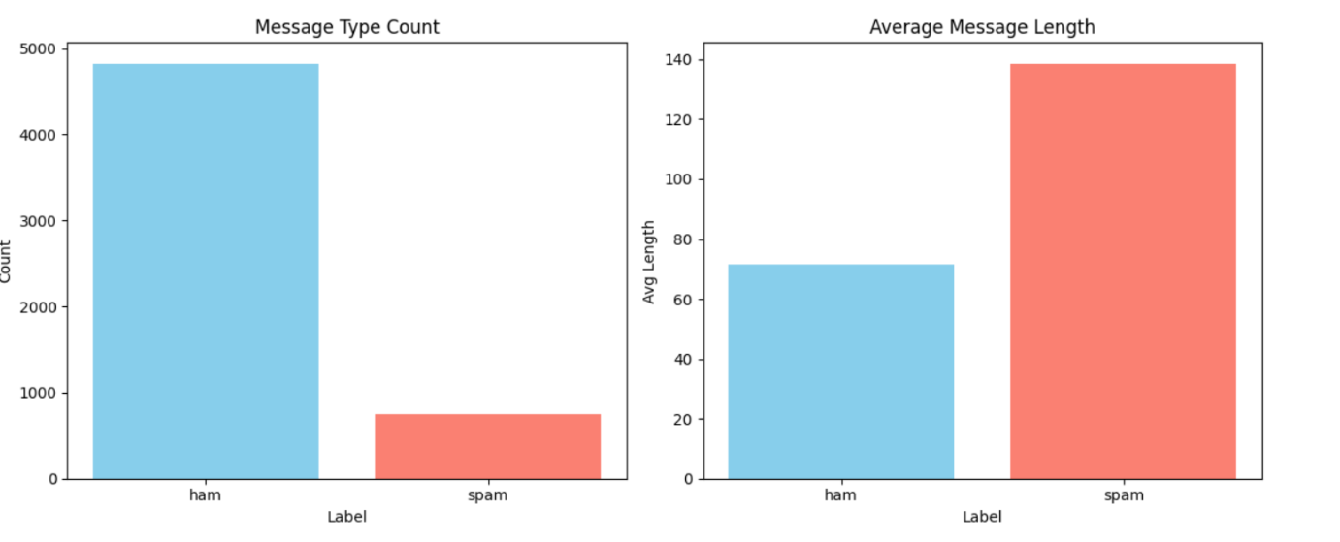
Output 8: Count plots for the categorical columns

From the above plots we can draw the following observations:
- Creates a synthetic dataset for one year (365 days starting from Jan 1, 2023).
- Temperature is modeled as a sine wave (seasonal variation) plus some noise.
- Energy_demand is roughly linearly dependent on temperature plus some random noise.
label_counts = df['label'].value_counts()
count_df = label_counts.reset_index()
count_df.columns = ['label', 'count']
plt.figure(figsize=(6, 5))
sns.barplot(x='label', y='count', data=count_df, palette='coolwarm')
plt.title('Spam vs Ham Message Count')
plt.xlabel('Message Type')
plt.ylabel('Count')
plt.tight_layout()
plt.show()

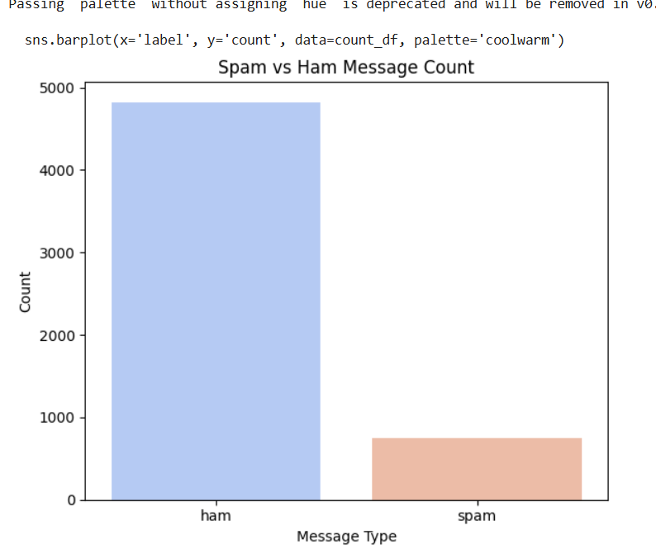
Output 9: Average energy demand

sns.histplot(data=df, x='msg_length', hue='label', kde=True, palette='coolwarm', bins=30)
plt.title('Distribution of Message Lengths by Label')
plt.xlabel('Message Length')
plt.ylabel('Frequency')
plt.tight_layout()
plt.show()
:
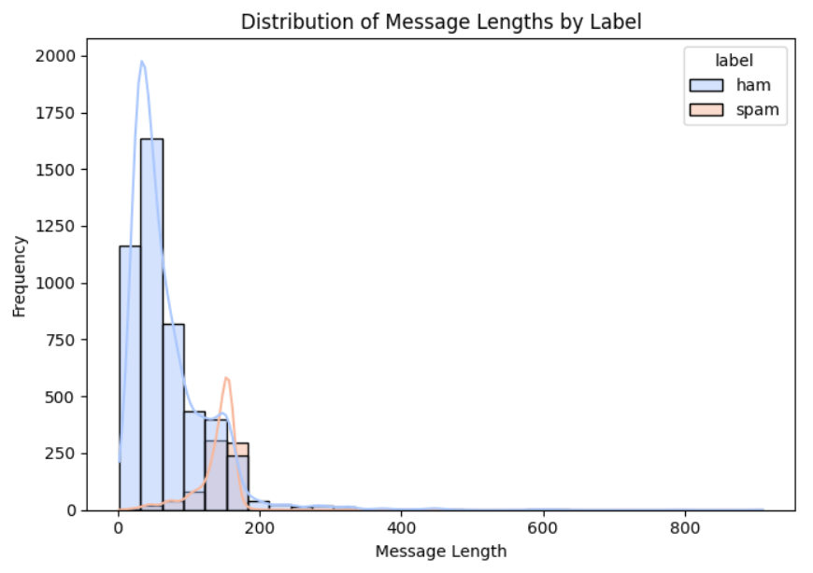output 10: Output 10: Distribution plot for the columns with continuous data
Both of the continuous data are skewed left one is positive and the right one is negatively skewed.
plt.figure(figsize=(8, 5))
sns.boxplot(x='label', y='msg_length', data=df, palette='coolwarm')
plt.title('Box Plot of Message Lengths by Label')
plt.xlabel('Message Type')
plt.ylabel('Message Length')
plt.tight_layout()
plt.show()
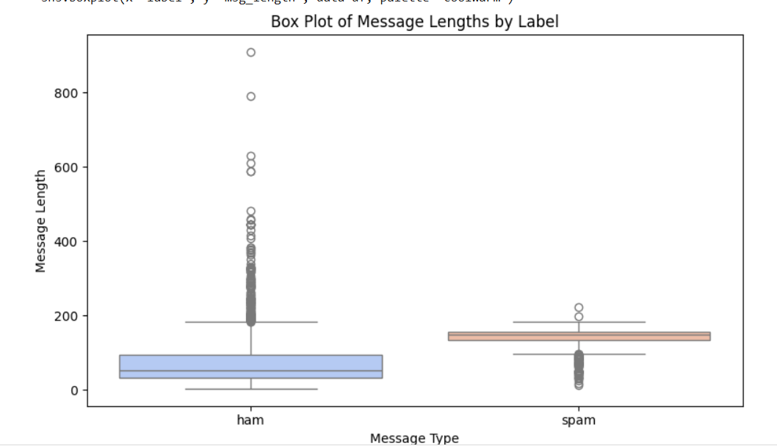Output 11: Box plots for the columns with continuous data

Step 5: Feature Engineering
Feature Engineeringhelps to derive some valuable features from the existing ones. These extra features sometimes help in increasing the performance of the model significantly and certainly help to gain deeper insights into the data.

df['msg_length'] = df['message'].apply(len) # Length of message
df['num_words'] = df['message'].apply(lambda x: len(x.split())) # Number of words
df['num_capitals'] = df['message'].apply(lambda x: sum(1 for c in x if c.isupper())) # Uppercase letters
df['num_digits'] = df['message'].apply(lambda x: sum(c.isdigit() for c in x)) # Digits
df['has_link'] = df['message'].apply(lambda x: int('http' in x or 'www' in x)) # Presence of a link
df['has_exclam'] = df['message'].apply(lambda x: int('!' in x)) # Presence of exclamation
df['avg_word_length'] = df['message'].apply(lambda x: sum(len(w) for w in x.split()) / len(x.split()) if x.split() else 0)

# Convert label to binary
df['label_binary'] = df['label'].map({'ham': 0, 'spam': 1})

# Display first few rows
print(df.head())
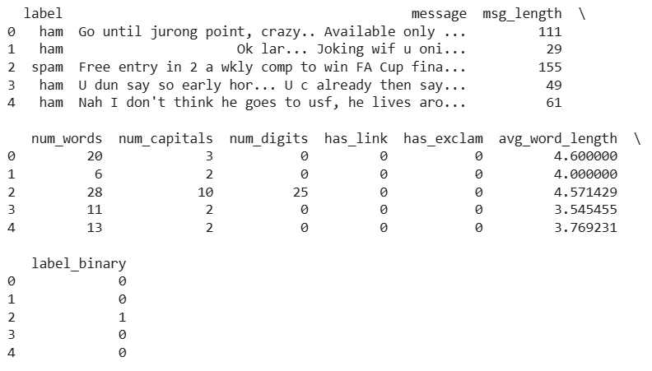
Output 12: Feature Engineering

corr = df[['msg_length', 'num_words', 'num_capitals', 'num_digits',
'has_link', 'has_exclam', 'avg_word_length', 'label_binary']].corr()

# Plot heatmap
plt.figure(figsize=(6, 6))
sns.heatmap(corr, annot=True, cmap='coolwarm', fmt=".2f", linewidths=0.5)
plt.title('Feature Correlation Heatmap')
plt.tight_layout()
plt.show()

# Making a heatmap to visualize the correlation matrix
plt.figure(figsize=(10,10))
sb.heatmap(df.corr() > 0.8, annot=True, cbar=False)
plt.show()
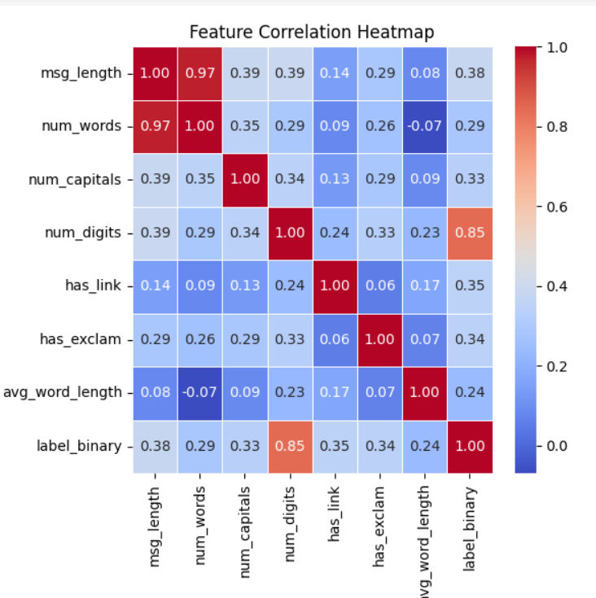
Output 15: Heat map for the highly correlated features

From the above heat map we can see that there are only one highly correlated features which we will remove before training the model on this data as highly correlated features do not help in learning useful patterns in the data.

Step 6: Model Training

Now we will separate the features and target variables and split them into training and the testing data by using which we will select the model which is performing best on the validation data.
df['msg_length'] = df['message'].apply(len)
df['num_words'] = df['message'].apply(lambda x: len(x.split()))
df['num_capitals'] = df['message'].apply(lambda x: sum(1 for c in x if c.isupper()))
df['num_digits'] = df['message'].apply(lambda x: sum(c.isdigit() for c in x))
df['has_link'] = df['message'].apply(lambda x: int('http' in x or 'www' in x))
df['has_exclam'] = df['message'].apply(lambda x: int('!' in x))
df['avg_word_length'] = df['message'].apply(lambda x: sum(len(w) for w in x.split()) / len(x.split()) if x.split() else 0)
df['label_binary'] = df['label'].map({'ham': 0, 'spam': 1})

# Feature set and target
features = ['msg_length', 'num_words', 'num_capitals', 'num_digits',
'has_link', 'has_exclam', 'avg_word_length']
X = df[features]
y = df['label_binary']

# Train-test split
X_train, X_test, y_train, y_test = train_test_split(X, y, test_size=0.2, random_state=42)

# Model training
model = LogisticRegression(max_iter=1000)
model.fit(X_train, y_train)

# Predictions
y_pred = model.predict(X_test)

# Evaluation
print("Accuracy:", accuracy_score(y_test, y_pred))
print("\nClassification Report:\n", classification_report(y_test, y_pred))
print("\nConfusion Matrix:\n", confusion_matrix(y_test, y_pred))

from the minority class and repeat it multiple times so, that the two classes get balanced.
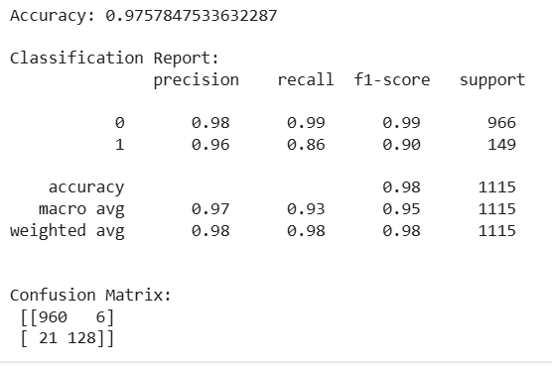
Output 1.5: Model Performance
From the above accuracies can that Logistic Regression classifier perform better on the validation data with less difference between the validation and training data. The disease for which there are no diagnostics methods machine learning models are able to predict whether the person has Autism or not. This is where machine learning helps in real-world problems and solving them.
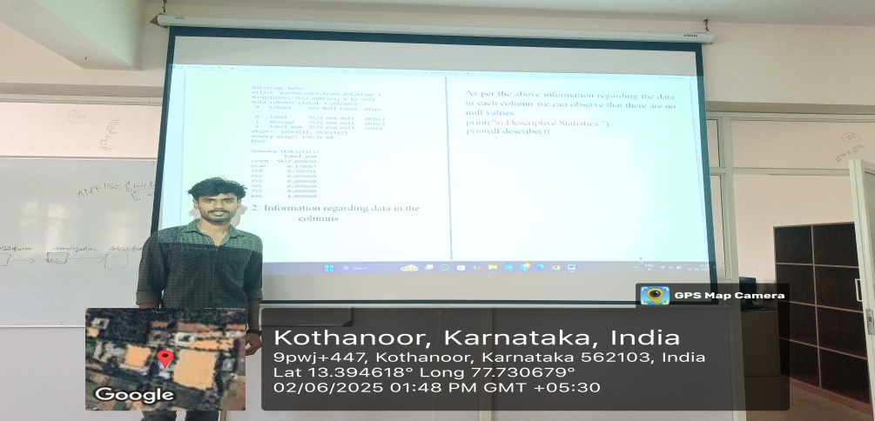
Fig 1.6 Spam Email Detection using Machine Learning
Course Outcomes:
1.Describe the machine learning techniques, their types and data analysis framework.
2. Apply mathematical concepts for feature engineering and perform dimensionality reduction to enhance model performance.
3. Develop similarity-based learning models and regression models for solving classification and prediction tasks.
4. Build probabilistic learning models and design neural network models using perceptrons and multilayer architectures.
5. Utilize clustering algorithms to identify patterns in data and implement reinforcement learning techniques
This Problem statement is mapped to the following CO’s and PO’s:

Mapped CO | PO

Particular | Presentation  ( 2M) | Program design  (3M) | Questionnaires  (2M) | Report  (3M) | Total  (10M) | Signature
Subject Teacher Marks
Reviewer Marks

